Issues in Mental Health
OCR A level Component 3



Paper 3  Candidates should be able to: - | GREEN | AMBER | RED
Issues in Mental Health Section A
- The historical context of mental health
Historical views of mental illness
Defining abnormality
Categorising mental disorders
Rosenhan (1973)
On being sane in insane places.
Characteristics of an affective disorder, a psychotic disorder and an anxiety disorder.
- The medical model
The biochemical explanation of mental illness
The genetic explanation of mental illness
Brain abnormality as an explanation of mental illness
Gottesman et al. (2010)
Disorders in offspring with two psychiatrically ill parents.
Biological treatment of one specific disorder.
- Alternatives to the medical model
The behaviourist explanation of mental illness
The cognitive explanation of mental illness
The psychodynamic explanation of mental illness
Szasz (2011) The myth of mental illness: 50 years later.
Non-biological treatment of one specific disorder.

- The Historical Context of Mental Illness

Mad or bad?
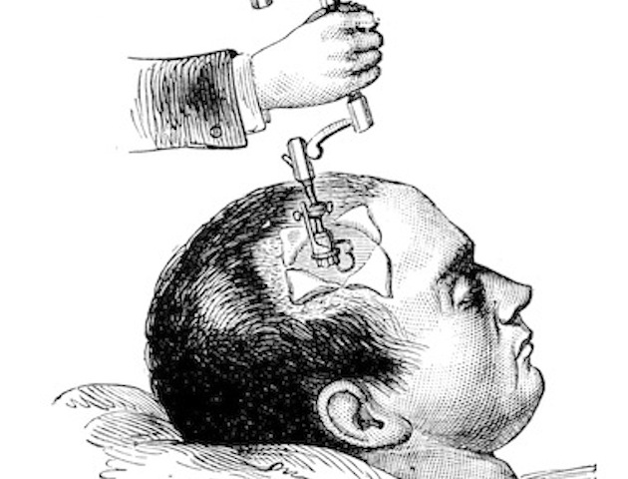
Views on the causes and treatment of mental illness vary across historical time and across cultures. There is evidence from skulls dating back to the prehistoric era that trepanning (drilling holes in the skull) was practiced to release demons from people and, even more surprising, that as some of the skulls showed evidence of healing, some even survived the procedure.

In the bible the use of the term ‘madness’ in the Old Testament is used to cover all psychotic and neurotic illness and is seen as a punishment from God. This belief of mental illness as a punishment from God was common in lots of cultures and led to the widespread mistreatment of the mental ill. During the Middle Ages mental illness could have fatal consequences, many mental ill women (and some men) were burnt at the stake as witches.

Hippocrates (460-377BC) thought madness resulted from an imbalance of the four humours: - blood, phlegm, yellow bile and black bile. Depression was thought to be caused by an excess of black bile. Treatments to restore balance included diet and bloodletting.

Eventually, towards the end of the 18th century and the beginning of the 19th century, a more enlightened view of mental illness arose. This considered the role of emotions, stressors and even inheritance. This led to the more humane treatment of the mentally ill. In 1796 the Tukes founded the York retreat the first institution for the humane treatment of the mentally ill in Britain. This continued into the 19th century when the ‘insane poor’ were treated according to the principles of moral treatment.

Psychiatry and modern psychology began in 1890s, the dominant approach being the medical model. The medical model suggests that most mental illness has a biological cause and therefore treatments should also be predominately biological.

The biological model is still dominant in modern psychiatry, with chemical treatments used extensively. However, there is now an acceptance that non-biological therapies such as CBT (Cognitive Behaviour Therapy) can be equally important.



Definitions of Abnormality

- Abnormality is difficult to define. Views of abnormality change across cultures vary within cultures over time and vary from group to group (e.g. Chavs and Goths) within the same society (cultural relativism). It is essential to examine views of abnormality as they form the basis for defining and identifying psychological disorders.
- How do we decide what is ‘normal’ or ‘abnormal’, and whether the behaviour constitutes a psychological disorder (e.g. depression, schizophrenia, phobias, post-traumatic stress disorders, eating disorders etc.)

- Statistical Infrequency


A norm is a standard or rule that regulates behaviour in a social setting e.g. it is the norm in our society to be polite and say please and thank you. Norms are socially acceptable or ‘normal’ standards of behaviour. Abnormality is defined as moving away from the norm, non-compliance with society’s norms and values. In statistical terms human behaviour is abnormal if it falls outside the range that is typical for most people, in other words the average is ‘normal’. Things such as height, weight and intelligence fall within fairly broad areas. People outside these areas might be considered abnormally tall or short, fat or thin, clever or unintelligent etc. In statistical terms they are abnormal because their behaviour has moved away from the norm.

Example: - The Normal Distribution Curve for IQ

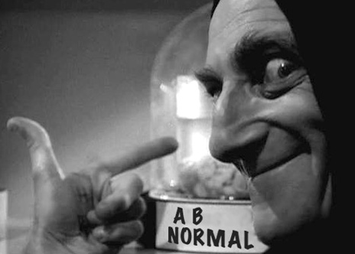
IQ is calculated using psychometric intelligence tests. These tests give a mental age, this is divided by chronological age and multiplied by 100 to give an IQ score e.g. mental age 20/chronological age 17 X 100 = 118. This means that the norm for IQ is 100 because if mental age and chronological age match IQ is 100 e.g. mental age 17/chronological age 17 X 100 = 100. Anything between 70 and 130 is considered normal for IQ, an IQ of less than 70 or more than 130 is statistically infrequent and therefore considered abnormal.

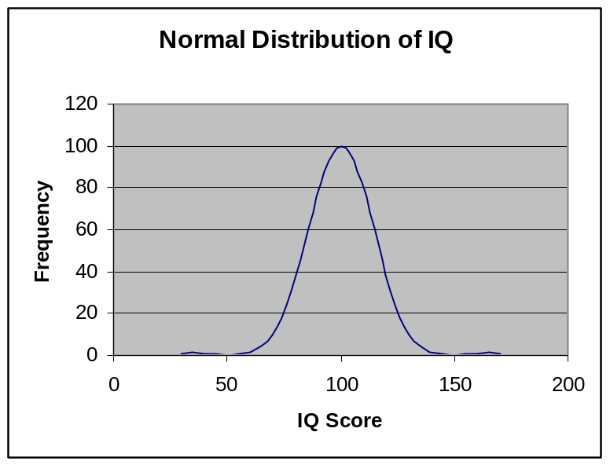
Mark on the graph the norm or average IQ score and the cut off points for abnormality (e.g. 100, 70 and 130).

Limitations: How is statistical infrequency limited as a definition of abnormality?

- The cut off points are rather arbitrary. How can someone with an IQ of 70 be considered normal, whilst a person with an IQ of 1 point difference (69) be considered abnormal?
- It ignores desirability of behaviour, in terms of IQ we might accept that someone has an abnormally low IQ, but we would probably all wish to have a high IQ and wouldn’t label that as abnormal.
- Some disorders, for example depression, are statistically very frequent, but still classified as abnormal.
- Cultural and historical relativism: - what is statistically frequent and acceptable in one culture and time period is not necessarily the norm in another. For example, arranged marriages are statistically frequent in India, Marijuana smoking is statistically frequent in Jamaica.

Strength
- Sometimes it is appropriate to use statistical criterion to define abnormality. E.g. intellectual disability. Any individual whose IQ is more than 2 standard deviations below the mean is judged as having a mental disorder. Why is this useful?

- Deviation from Social Norms

Every society or culture has standards of acceptable behaviour/norms. Behaviour that deviates (moves away) from these norms is considered abnormal. These standards are in place for good reasons e.g. politeness. Those who aren’t polite are considered to behave in a socially deviant way as others find it difficult to interact with rude people. Some rules about unacceptable behaviour are implicit whereas others are policed by laws.

Social norms are approved and expected ways of behaving in a particular society or social situation. For example, in all societies there are social norms governing dress for different ages, gender and occasions.

Examples for deviation from social norms

A past example of deviating from social norms would have been homosexuality. Many thought homosexuals had a mental illness. Today, a good example of deviating from social norms would be anti-social personality disorder. According to the DSM-5 one important symptom of antisocial personality disorder is an “absence of prosocial internal standards associated with failure to conform to lawful or culturally normative ethical behaviour.” So we are making the social judgement that a psychopath is abnormal because they don’t conform to our moral standards

Task: - Think of specific occasions where social norms govern appropriate dress.

Task: - In pairs, using the evaluation we did together of statistical infrequency as a guide discuss the limitations of this definition and note them in the box below.
Evaluation: -

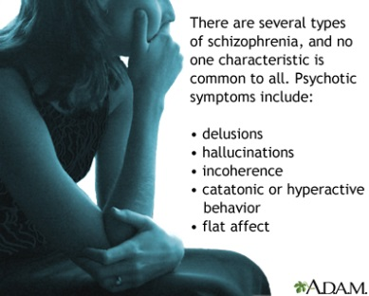
- Failure to Function Adequately

From an individual’s point of view, abnormality can be judged in terms of not being able to cope with everyday living i.e. a failure to function adequately.
So ‘functioning’ refers to just going about your day-to-day life such as eating regularly, washing clothes, getting up to go to a job or some activity, communicating with others etc.
Not functioning adequately causes distress & suffering for the individual and may cause distress for others. It’s important to included distress for others because sometimes the individual who isn’t functioning may not be distressed at all as they lack insight into their condition e.g. schizophrenia.
There may be situations where a person is not coping with everyday life in a ‘normal’ way E.g. someone might be content living in unwashed clothes and not holding down a job. If it doesn’t cause distress to themselves or others, a judgement of abnormality is inappropriate.

So when is someone failing to function adequately?
Rosenhan and Seligman (1989) proposed some signs that can be used to determine when someone is not coping:
- When someone no longer conforms to standard interpersonal rules e.g. maintaining eye contact & respecting personal space.
- When a person experiences severe personal distress.
- When a person’s behaviour becomes irrational or dangerous to themselves or others.

Strengths of failing to function adequately

- This definition of abnormality does recognise the subjective experience of the individual, allowing us to view mental disorder from the point of view of the person experiencing it. So it acknowledges that the experience of the patient is important.
- In addition, failure to function adequately is also relatively easy to judge objectively because we can list behaviours (can dress self, can prepare meals etc.) and thus judge abnormality objectively.

Limitations of failing to function adequately
- Subjective judgement – someone has to judge whether a patient is distressed or distressing. Some patients may say they’re distressed but may not be judged as suffering. There are methods to make such judgements more objective including checklists such as the Global Assessment of Functioning Scale. However, it still remains whether someone e.g. a psychiatrist, has the right to make this judgement.

- Is it really failing to function or just deviating from social norms? It can be hard to say when someone is really failing to function or just deviating from social norms. People who live alternative lifestyles or do extreme sports could be seen as behaving maladaptively. If we treat these behaviours as ‘failures’ of adequate functioning we may limit freedom.
- Cultural relativism – this definition is likely to result in different diagnoses when applied to people in different cultures because the standard in one culture is being used to measure another.

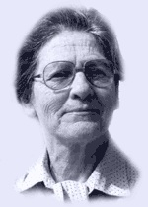
- Deviation from Ideal Mental Health

So far we have outlined definitions of abnormality. This definition instead attempts to define normality, and assumes that absence of normality indicates abnormality. However, normality is as difficult to define as abnormality. Jahoda (1958) approached this problem by identifying various factors that were necessary for ‘optimal living’ (maximising enjoyment for life). The presence of these factors indicates psychological health and well-being. Jahoda (1958) pointed out that we define physical illness in part by looking at the absence of signs of physical health. So why not do the same for mental illness?
Jahoda conducted a review of what others had written about good mental health. These are the characteristics that enable an individual to feel happy (free from distress) and behave competently.

Jahoda’s 6 elements of Optimal Living

- Self attitudes: having high self esteem and a strong sense of identity.
- Personal growth and self actualisation: the extent to which an person develops their full capabilities.
- Integration: such as being able to cope with stressful situations.
- Autonomy: being independent and self-regulating.
- Having an accurate perception of reality.
- Mastery of the environment: including the ability to love, function at work and in interpersonal relationships, adjust to new situations and solve problems.

Task: - Consider each of these 6 factors in turn. Are you normal? What are the limitations of Jahoda’s elements of optimal living?

Strengths of deviation from ideal mental health
- It’s a positive approach and offers an alternative perspective on mental disorder by focusing on the positives rather than the negatives (focuses on what’s desirable than what is not). The ideas have had some influence and are in accord with the ‘positive psychology’ movement.

Limitations of deviation from ideal mental health

- Unrealistic criteria: According to these criteria, most of us are abnormal! Jahoda presented them as ideal and they certainly are! We also have to ask how many need to be lacking before a person would be judged as abnormal.
- Suggests that mental health is the same as physical health: In general, physical illnesses have physical causes such as virus or bacterial infection and this makes them relatively easy to detect and diagnose. It’s possible that some mental disorders have physical causes but many do not. They are the consequence of life experiences. So it’s unlikely we could diagnose in the same way.
- Cultural relativism: If we applied these criteria to people from non-western or even non-middle-class social groups, we will most probably find a higher incidence of abnormality. E.g. the criteria for self-actualisation is relevant to individualist cultures but not collectivist, where individuals strive for the greater good of the community rather than for self-centred goals.

A Note On Cultural Relativism!

Cultural Relativism: - Every definition of abnormality is limited by cultural differences - you just have to be specific when talking about each definition and explain why. What is or is not considered psychological abnormality is mediated by cultural norms and values – this is known as cultural relativism – what is normal and acceptable in one culture is not necessarily in another.


Culture refers to all ways of thinking, feeling and acting that people learn from other members of society. Different cultures will show cross-cultural differences in beliefs, traditions, norms etc. and may have different views on defining and classifying abnormality. For example, in the West Indies it is perfectly acceptable to admit to hearing voices, it is considered a religious experience, people pray and God answers them. In Britain, hearing voices is considered a symptom of schizophrenia.


Subculture: - This refers to a social group within a society e.g. gender, social class, age and ethnic groups. The dominant culture within a society is likely to be seen as the norm and subcultures as abnormal. The frequency of mental disorders can vary in relation to subcultures. For example, schizophrenia is between twice and eight times more prevalent in lower socio-economic groups in society. Rack (1984) found that African Caribbean’s in Britain are sometimes diagnosed as mentally ill, on the basis of behaviour which is perfectly normal within their subculture (hearing voices and smoking marijuana (cannabis psychosis). Women are also more likely than men to be diagnosed with clinical depression. Some mental disorders have been found to be specific to certain cultures. The term given to these disorders is Culture Bound Syndromes (CBS), for example PMT and Anorexia Nervosa are particularly Western disorders.

Categorising Mental Illness

DSM (diagnostic and statistical manual of mental disorders) 5 and ICD (international classification of diseases) are like medical dictionaries used to help clinicians diagnose mental illness. Each disorder will have a list of possible symptoms.

Task: -

Many of you will have used ‘Doctor Google’ when feeling unwell. What are the main issues and problems with looking up symptoms and trying to diagnose conditions?

DSM-V (2013) Diagnosis of Schizophrenia

Criterion A
Two (or more) of the following symptoms:
- Delusions
- Hallucinations
- Disorganised Speech (e.g. frequent derailment or incoherence)
- Grossly disorganised or catatonic behaviour
- Negative symptoms i.e. affective flattening, alogia or avolition.

Note: Only one criterion A symptom is required if delusions are bizarre or hallucinations consist of a voice keeping up a running commentary on the person’s behaviour or thoughts, or two or more voices conversing with each other.

Criterion B: Social/Occupational Dysfunction
For a significant portion of the time since onset, one or more major areas of functioning such as work, interpersonal relations or self-care are markedly below the level achieved prior to onset.

Criterion C: Duration
Continuous signs of disturbance persist for at least 6 months. This 6 month period must include at least 1 month of symptoms (or less if successfully treated) that meet Criterion A.
During non-active periods, disturbance may be limited to negative symptoms or two or more symptoms in Criterion A in attenuated form (e.g. odd beliefs, unusual perceptual experiences).

Reliability and Validity in Diagnosis and Classification

Classification systems such as DSM-V are worthless unless they’re reliable. Reliability refers to the consistency of a classification system such as DSM e.g. to assess particular symptoms of schizophrenia. Reliability alone counts for nothing unless these systems and scales are also valid. Validity refers to the extent that a diagnosis represents something that is real and distinct from other disorders and the extent that a classification system such as DSM measures what it claims to measure. Reliability and validity are inextricably linked because a diagnosis cannot be valid if it’s not reliable.

Reliability
Diagnostic reliability means that a diagnosis of schizophrenia must be repeatable i.e. clinicians must be able to reach the same conclusions at 2 different points in time (test-retest reliability) or different clinicians must reach the same conclusions (inter-rater reliability). Inter-rater reliability is measured by a statistic called a kappa score. A score of 1 indicates perfect inter-rater agreement; a score of 0 indicates zero agreement. A kappa score of 0.7 or above is generally considered good. In the DSM-V field trials (Regier et al 2013), the diagnosis of schizophrenia had a kappa score of only 0.46.

Reliability - Cultural differences in diagnosis
Research suggests there is a significant variation between countries when it comes to diagnosing schizophrenia i.e. culture has an influence on the diagnostic process. Copeland (1971) gave 134 US and 194 British psychiatrists a description of a patient. 69% of the US psychiatrists diagnosed schizophrenia, but only 2% of the British ones gave the same diagnosis. One of the main characteristics of schizophrenia, ‘hearing voices,’ also appears to be influenced by cultural environment. Luhrman et al (2015) interviewed 60 adults diagnosed with schizophrenia, 20 each in Ghana, India and the US. Each was asked about the voices they heard. Strikingly, while many of the African and Indian subjects reported positive experiences with their voices, describing them as playful or offering advice, not one American did. Rather the US subjects were more likely to report the voices they heard as violent and hateful – and indicative of being ‘sick.’ Luhrman suggests that the ‘harsh, violent voices so common in the West may not be an inevitable feature of schizophrenia’. This suggests that schizophrenia has a lack of consistent characteristics.

It was originally hoped that the use of diagnostic tools (DMS and ICD) could provide a standardised method of recognising mental disorders. However, the behaviour of an individual is always open to some interpretation. The process is actually more subjective than we hoped. The most famous study testing the subjectivity, reliability and validity of diagnostic tools was Rosenhan et al (1972).

Validity
Are we measuring what we’re claiming to measure? Is the diagnosis an accurate reflection of the disorder and is the diagnosis distinct from other disorders?

Validity – Gender Bias in diagnosis

Gender bias in the diagnosis of schizophrenia is said to occur when accuracy of diagnosis is dependent on the gender of an individual. The accuracy of diagnostic judgements can vary for a number of reasons, including gender biased diagnostic criteria or clinicians basing their judgements on stereotypical beliefs held about gender. For example, critics of the DSM diagnostic criteria argue that some diagnostic categories are biased toward pathologising one gender rather than the other. Broverman et al (1970) found that clinicians in the US equated mentally healthy ‘adult’ behaviour with mentally healthy ‘male’ behaviour. As a result, there is a tendency for women to be perceived as less mentally healthy.
Longenecker et al (2010) reviewed studies of the prevalence of schizophrenia and found that, since the 1980s, men have been diagnosed with schizophrenia more often than women (prior to this there seems to be no differences). It may be that men are more genetically vulnerable to developing it than women but another explanation for this gender-bias could be that female patients typically function better than men, be more likely to work and have good family relationships (Cotton et al 2009). This high functioning could explain why some women have not been diagnosed with schizophrenia where men with similar symptoms may have been; their better interpersonal functioning may bias practitioners to under-diagnose schizophrenia, either because symptoms are masked by good interpersonal functioning, or because the quality of interpersonal functioning makes the case seem too mild to warrant a diagnosis.

Validity – Symptom Overlap
Despite the claim that the classification of positive and negative symptoms would make for more valid diagnoses of schizophrenia, many of these symptoms are also found in other disorders, such as depression and bipolar disorder. The problem is referred to as ‘symptom overlap.’ For example, Ellason and Ross (1995) point out that people with dissociative identity disorder (DID) actually have more schizophrenic symptoms than people diagnosed as being schizophrenic! Most people diagnosed with schizophrenia have sufficient symptoms of other disorders that they could also receive at least one other diagnosis (Read, 2004).

Validity - Co-Morbidity
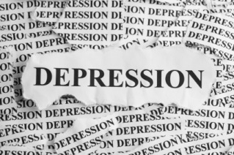
Co-morbidity is an important issue for the validity of the diagnosis of mental illness. It refers to the extent that 2 or more conditions can occur at the same time. Psychiatric co-morbidities are common among patients with schizophrenia. These include substance abuse, anxiety and symptoms of depression. For example, Buckley et al (2009) estimate that co-morbid depression occurs in 50% of patients, and 47% of patients also have a lifetime diagnosis of co-morbid substance abuse.
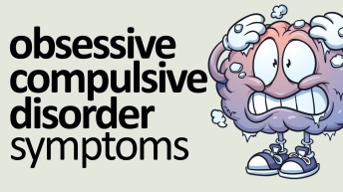
Schizophrenia and obsessive-compulsive disorder (OCD) are 2 distinct psychiatric conditions. Roughly 1% of the population develop schizophrenia, and roughly 2-3% develop OCD. Since both are fairly uncommon, we would expect that only a few people with schizophrenia would develop OCD and vice versa. However, evidence suggests that the 2 conditions appear together more often than chance would suggest. A meta-analysis by Swets et al (2014) found that at least 12% of patients with schizophrenia also fulfilled the diagnostic criteria for OCD and about 25% displayed significant obsessive-compulsive symptoms.
If conditions occur together a lot of the time then this calls into question the validity of their diagnosis and classification because they might actually be a single condition. It poses a challenge for the diagnosis of schizophrenia. If half the schizophrenia patients are also diagnosed with depression then maybe we are just quite bad at telling the difference between the 2 conditions. In terms of classification, it may be that, if very severe depression looks a lot like schizophrenia and vice versa, then they might be seen as a single condition. This confusing picture is a weakness of diagnosis and classification.

Rosenhan (1973) - On being sane in insane places.

Aim

The aim of this study was to test the hypothesis that psychiatrists cannot reliably tell the difference between people who are mentally ill and those who are not. Rosenhan used the terms sane and insane, although these are legal, not medical terms.

Method

The study actually consisted of two parts

The main study is an example of a field experiment. The manipulation (independent variable) was the made up symptoms of the pseudo (fake) patients, and the dependent variable was the psychiatrists' admission and diagnostic label of the pseudo patient. The study also involved participant observation, since, once admitted, the pseudo-patients kept written records of how the ward as a whole operated, as well as how they personally were treated.
The first part of the study involved eight sane (not mentally ill) people (a psychology graduate student in his 20s, three psychologists, a paediatrician, a psychiatrist, a painter, and a 'housewife') attempting to gain admission to 12 different hospitals, in five different states in the USA. There were three women and five men.
These pseudo-patients telephoned the hospital for an appointment, and arrived at the admissions office complaining that they had been hearing voices. They said the voice, which was unfamiliar and the same sex as themselves, was often unclear but it said 'empty', 'hollow', 'thud'.
The pseudo patients gave a false name and job (to protect their future health and employment records), but all other details they gave were true including general ups and downs of life, relationships, events of life history and so on.
After they had been admitted to the psychiatric ward, the pseudo patients stopped simulating any symptoms of abnormality. However, Rosenhan did note that the pseudo patients were nervous, possibly because of fear of being exposure as a fraud, and the novelty of the situation.
The pseudo patients took part in ward activities, speaking to patients and staff as they might ordinarily. When asked how they were feeling by staff they were fine and no longer experienced symptoms. Each pseudo patient had been told they would have to get out by their own devices by convincing staff they were sane.
The pseudo patients spent time writing notes about their observations. Initially this was done secretly although as it became clear that no one was bothered the note taking was done more openly.
In four of the hospitals the pseudo patients carried out an observation of behaviour of staff towards patients that illustrate the experience of being hospitalised on a psychiatric ward. The pseudo patients approached a staff member with a request, which took the following form: 'Pardon me, Mr/Mrs/Dr X, could you tell me when I will be presented at the staff meeting?’ (or ‘…when am I likely to be discharged?’). See table 1.
Results
All of the pseudo patients disliked the experience and wished to be discharged immediately.
None of the pseudo patients was detected and all but one were admitted with a diagnosis of schizophrenia and were eventually discharged with a diagnosis of 'schizophrenia in remission'. This diagnosis was made without one clear symptom of this disorder. They remained in hospital for 7 to 52 days (average 19 days), Visitors to the pseudo patients observed ‘no serious behavioural consequences'. Although they were not detected by the staff, many of the other patients suspected their sanity (35 out of the 118 patients voiced their suspicions). Some patients voiced their suspicions very vigorously for example ‘You’re not crazy. You’re a journalist, or a professor. You’re checking up on the hospital’.
The pseudo patients’ normal behaviours were often seen as aspects of their supposed illness. For example, nursing records for three of the pseudo patients showed that their writing was seen as an aspect of their pathological behaviour. 'Patient engages in writing behaviour'. Rosenhan notes that there is an enormous overlap in the behaviours of the sane and the insane. We all feel depressed sometimes, have moods, become angry and so forth, but in the context of a psychiatric hospital, these everyday human experiences and behaviours were interpreted as pathological.
Another example of where behaviour was misinterpreted by staff as stemming from within the patient, rather than the environment, was when a psychiatrist pointed to a group of patients waiting outside the cafeteria half an hour before lunchtime. To a group of registrars (trainee psychiatrists) he suggested that such behaviour was characteristic of an oral-acquisitive syndrome. However, a more likely explanation would be that the patients had little to do, and one of the few things to anticipate in a psychiatric hospital is a meal.
In four of the hospitals the pseudo patients carried out an observation of behaviour of staff towards patients that illustrate the experience of being hospitalised on a psychiatric ward. The pseudo patients were often treated as if they were invisible. See table 1.
Table 1: Responses of staff towards pseudo patients’ requests
Response | Percentage making contact with patient
 | Psychiatrists | Nurses
Moves on with head averted | 71 | 88
Makes eye contact | 23 | 10
Pauses and chats | 2 | 4
Stops and talks | 4 | 0.5
Rosenhan noted that experience of hospitalisation for the pseudo patients was one of depersonalisation and powerlessness.
Powerlessness and depersonalisation were evident in the ways in which the patients were deprived of many human rights such as freedom of movement and privacy. Medical records were open to all staff members regardless of status or therapeutic relationship with the patient and personal hygiene was monitored and many of the toilets did not have doors. Some of the ward orderlies would be brutal to patients in full view of other patients but would stop as soon as another staff member approached. This indicated that staff were credible witnesses but patients were not.
It was estimated that the pseudo patients were given a total of 2,100 medication tablets, though only two were swallowed. The rest were either pocketed or flushed down the toilet. Often, when the pseudo patients visited the toilets to dispose of their tablets they found the medication of other patients that had already been placed there. As long as the patients were co-operative, then their behaviour went unnoticed.
The records the pseudo patients had made about the amount of time the nurses stayed in the ward offices was about 90 per cent of the time and the number of times medical staff came onto the ward, and the amount of time spent with psychiatrists, psychologists, registrars and so forth was, on average, under seven minutes per day.
The Secondary Study
Method
In the secondary study, the staff of a teaching and research hospital, which was aware of the first study, was falsely informed that during the next three months one or more pseudo patients would attempt to be admitted into their hospital. Staff members were asked to rate on a 10-point scale each new patient as to the likelihood of them being a pseudo patient.
This false information was the manipulated independent variable, and the dependent variable was the number of patients which staff subsequently suspected of being pseudo patients.
Results of the Secondary Study
The table shows that many patients of the hospitals regular intake were judged to be pseudo patients. For example, around ten per cent of their regular intake were judged by one psychiatrist and another staff member to be pseudo patients.
Table 2: Judgement of all admissions patients as to the likelihood that they are pseudo patients
Number of patients judged | 193
Number of patients confidently judged as pseudo patients by at least one staff member | 41
Number of patients suspected by one psychiatrist | 23
Number of patients suspected by one psychiatrist AND one other staff member | 19
Conclusions
Rosenhan claims that the study demonstrates that psychiatrists cannot reliably tell the difference between people who are sane and those who are insane.
The main experiment illustrated a failure to detect sanity (type II error false positive), and the secondary study demonstrated a failure to detect insanity (type I error false negative).
Rosenhan explains that psychiatric labels tend to stick in a way that medical labels do not and that everything a patient does is interpreted in accordance with the diagnostic label once it has been applied.
He suggested that instead of labelling a person as insane we should focus on the individual’s specific problems and behaviours.
Evaluation of the Procedure
Strengths
The participant observation meant that the pseudo patients could experience the ward from the patients’ perspective while also maintaining some degree of objectivity.
The study was a type of field experiment and was thus fairly ecologically valid whilst still managing to control many variables such as the pseudo patients’ behaviour.
Rosenhan used a range of hospitals. They were in different States, on both coasts, both old or shabby and new, research-orientated and not, well staffed and poorly staffed, one private, federal or university funded. This allows the results to be generalised.

Weaknesses
The hospital staff were deceived - this is, of course, unethical. Although Rosenhan did conceal the names of hospitals or staff and attempted to eliminate any clues which might lead to their identification
Rosenhan did note that the experiences of the pseudo-patients could have differed from that of real patients who did not have the comfort of knowing that the diagnosis was false.
Perhaps Rosenhan was being too hard on psychiatric hospitals, especially when it is important for them to play safe in their diagnosis of abnormality because there is always an outcry when a patient is let out of psychiatric care and gets into trouble. If you were to go to the doctors complaining of stomach aches how would you expect to be treated?
Doctors and psychiatrists are more likely to make a type II error (that is, more likely to call a healthy person sick) than a type I error (that is, diagnosing a sick person as healthy). This is because they want to err on the side of caution. In other words it is better to be safe than sorry.
When Rosenhan did his study the psychiatric classification in use was DSM-II. However, since then a new classification has been introduced which was to address itself largely to the whole problem of unreliability - especially unclear criteria. It is argued that with the newer classification DSM-III, introduced in the 1980s, psychiatrists would be less likely to make the errors they did. The DSM is currently in its fourth edition (DSM-IV)
Evaluation of Explanation
The study demonstrates both the limitations of classification and importantly the appalling conditions in many psychiatric hospitals. This has stimulated much further research and has led to many institutions improving their philosophy of care.
Rosenhan, like other anti-psychiatrists, is arguing that mental illness is a social phenomenon. It is simply a consequence of labelling. This is a very persuasive argument, although many people who suffer from a mental illness might disagree and say that mental illness is a very real problem

Characteristics of an affective disorder, a psychotic disorder and an anxiety disorder.

All mental disorders have certain characteristics. These can be classified as behavioural emotional and cognitive.

- Behavioral refers to how people act
- Emotional refers to how people feel
- Cognitive refers to how people think

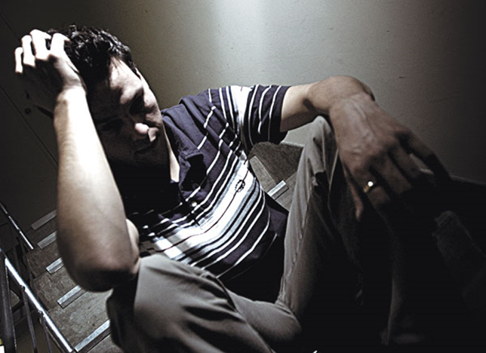
Depression is a mood or affective disorder. It involves a prolonged and fundamental disturbance of mood and emotion. Depressive disorders are the most common of all the psychopathological disorders. In Britain it is estimated that 1 in 20 adults (5%) suffers from depressive illness at any one time.

There are no laboratory tests to diagnose depression so doctors diagnose from behaviour and what patients tell them. This means that it is difficult for doctors to distinguish between the least severe cases of depression and a bad attack of ‘the blues’.

In order to be suffering from clinical depression a person should have experienced at least five of the following symptoms and a persistent low mood over at least two weeks.

1. Poor appetite or weight loss or increased appetite and weight gain.
2. Sleep difficulty or sleeping too much.
3. Loss of energy, tiredness.
4. Body slowed down or agitated (speeded up).
5. Loss of interest or pleasure in usual activities e.g. social contact and sex.
6. Feelings of self-reproach, excessive or inappropriate guilt.
7. Inability to concentrate or think clearly.
8. Recurrent thoughts of death or suicide or suicidal behaviour.

Task: - Classify these symptoms into behavioural, emotional and cognitive symptoms

According to MIND 2.6% of the UK population suffers from Clinical Depression. DSM V distinguishes between major depressive disorder and persistent depressive disorder which is long term and/or recurring.

Emotional characteristics of Depression
Sadness (lowered mood) is the most common description people give their depressed state, along with feeling empty. Associated with this people may feel worthless, hopeless and/or have lowered self-esteem – all negative emotions. Some have a sense of self-loathing i.e. hating themselves. Loss of interest and pleasure in usual hobbies and activities is associated with feelings of despair and lack of control.
Anger is also associated with depression – directed towards others or turned inwards on the self. On occasion such emotions lead to aggressive behaviour or self –harming behaviour. Depression may arise from feelings of being hurt and wishing to retaliate.

Behavioural Characteristics of Depression
There is a shift in activity level - either reduced or increased. Many depressed individuals experience reduced energy, a sense of tiredness and a wish to sleep all the time. However, some become increasingly agitated, restless, may pace around a room (psychomotor agitation) or tear at skin. Sleep may be affected – some people sleep much more (hypersomnia) and some find it difficult to sleep – insomnia or have premature waking. Appetite may also be affected – in some appetite is reduced whereas others eat considerably more than usual. Either way – these behaviours are disrupted. Aggression and self-harm – sufferers can often be irritable and in some cases become physically or verbally aggressive. Some direct harm to themselves by cutting themselves or suicide attempts.

Cognitive Characteristics of Depression
Depressed individuals tend to process information differently to others.
The negative emotions related to depression are associated with negative thoughts, such as negative self-concept (negative beliefs) as well as guilt, a sense of worthlessness and so on. Depressed people often have a negative view of the world and expect things to turn out badly rather than well. People have negative expectations about their lives, relationships & the world generally. Such expectations can be self-fulfilling. Such thoughts are irrational. Poor levels of concentration are associated with depression. They might find it difficult to stick with a task as they usually would or find it hard to make decision that would normally be straightforward. They might dwell on the negatives rather than the positives. They also may have absolutist thinking.

Schizophrenia is a severe psychotic mental disorder characterised by profound disruption of cognition and emotion. This affects a person’s language, thought, perception, emotions and even their sense of self. The schizophrenic believes things that cannot possibly be true (delusions) or hears voices or sees visions when there are no sensory stimuli to create them (hallucinations). Schizophrenia ranks among the top ten cases of disability worldwide and affects about 4 in 1000 people at some time in their lives (Saha et al, 2005)

The nature of schizophrenia
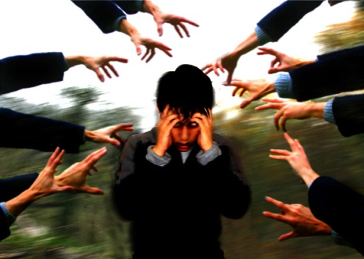
Schizophrenia is a type of psychosis, a severe mental disorder in which thoughts and emotions are so impaired that contact is lost with external reality. Schizophrenia is the most common psychotic disorder, affecting about 1% of the population. Schizophrenia is most often diagnosed between the ages of 15 and 35, with men and women affected equally. Someone with schizophrenia would characteristically experience delusions (a belief in something that is not, nor could be, true) and hallucinations (experiencing stimuli that are not present). There are many symptoms of the disorder, although not every patient displays all the symptoms.

Diagnosing schizophrenia
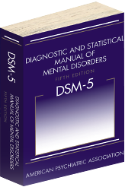
In order to make a diagnosis of schizophrenia, a clinician would use a diagnostic manual such as the DSM-V. DSM (the diagnostic and statistical manual of psychiatric disorders) is a classification and description of over 200 mental disorders, grouped in terms of their common features. Version 5 (DSM-V) is the most recent update. DSM is mostly used in the US, whereas in Europe ICD (international classification of diseases) is more commonly used. The most recent update of ICD is ICD-10, with ICD-11 due to be published in 2017. The symptoms are divided into positive and negative symptoms.

Positive Symptoms
Positive symptoms are those that appear to reflect an excess or distortion of normal functions. They include the following:


Hallucinations – bizarre, unreal perceptions of the environment that are usually auditory (hearing voices) but may also be visual (seeing lights, objects or faces that others can’t see), olfactory (smelling things that others can’t), or tactile (e.g. feeling that bugs are crawling under the skin or something touching the skin). Many schizophrenics report hearing a voice or several voices, telling them to do something (such as harm themselves or someone else) or commenting on their behaviour.

Delusions – bizarre beliefs that seem real to the person with schizophrenia, but they aren’t real. Sometimes these delusions can be paranoid (i.e. persecutory in nature). This often involves a belief that the person is being followed or spied upon by someone else. They may believe that their phone is tapped or there are video cameras hidden in their home. Delusions may also involve inflated beliefs about the person’s power and importance (delusions of grandeur). E.g. the person may believe that they are famous or have special powers or abilities. An individual may also experience delusions of reference, when events in the environment appear to be directly related to them, e.g. special personal messages are being communicated through the TV or radio.

Disorganised speech – is the result of abnormal thought processes, where the individual has problems organising his or her own thoughts and this shows up in their speech. They may slip from one topic to another (derailment), even in mid-sentence, and in extreme cases their speech may be so incoherent that it sounds like complete gibberish – something that is often referred to as ‘word salad.’

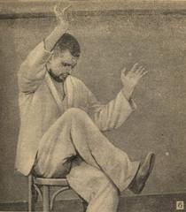
Grossly disorganised or catatonic behaviour – includes the inability or motivation to initiate a task, or to complete it once it’s started which leads to difficulties in daily living and can result in decreased interest in personal hygiene. The individual may dress or act in ways that appear bizarre to other people, such as wearing heavy clothes on a hot summer’s day. Catatonic behaviours are characterised by a reduced reaction to the immediate environment, rigid postures or aimless motor activity.


Negative Symptoms
These symptoms are those that appear to reflect a reduction or loss of normal functions, which often persist even during periods of low (or absent) positive symptoms. About 1 in 3 schizophrenia patients suffer from significant negative symptoms (Makinen et al, 2008). Negative symptoms weaken the person’s ability to cope with everyday activities, affecting their quality of life and their ability to manage without significant outside help. Individuals with schizophrenia are often unaware of the extent of their negative symptoms, and are typically less concerned about them than their relatives may be.
Enduring negative symptoms are often referred to as the ‘deficit syndrome’, characterised by the presence of at least 2 negative symptoms for 12 months or longer. Individuals with the deficit syndrome have been found to have more pronounced cognitive deficits and poorer outcomes than patients who don’t have this syndrome, with several studies (Milev et al, 2005) reporting worse functional outcomes in individuals with more prominent negative symptoms. Negative symptoms respond poorly to antipsychotic treatment, although the newer ‘atypical drugs’ are claimed to be superior in this respect than the older ‘typical’ drugs.

Negative symptoms include:
Speech poverty (alogia) – characterised by the lessening of speech fluency and productivity, this is thought to reflect slowing or blocked thoughts. Patients who display speech poverty display a number of characteristic signs. They may produce fewer words in a given time on a task of verbal fluency (e.g. name as many animals as you can in one minute). This is not a matter of now knowing as many words as non-schizophrenics but more a difficulty of spontaneously producing them. Speech poverty may also be reflected in less complex syntax e.g. fewer clauses, shorter utterances, etc. this type of speech appears to be associated with long illness and earlier onset.

Avolition – a reduction of interests and desires as well as an inability to initiate and persist in goal-directed behaviour (e.g. sitting in the house for hours every day doing nothing). Avolition is distinct from poor social function or disinterest, which can be the result of other circumstances. E.g. an individual may have no social contact with family or friends because they have none, or communication with them is difficult. This would not, however, be considered avolition, which is specified as a reduction in self-initiated involvement in activities that are available to the patient.

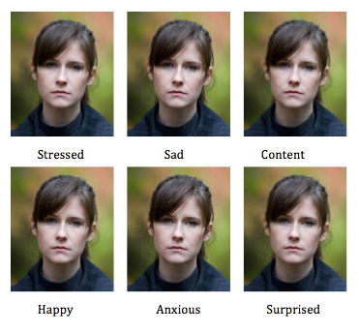
Affective flattening – a reduction in the range and intensity of emotional expression, voice tone, eye contact and body language. Compared to controls without this symptom, individuals show fewer body and facial movements and smiles, and less co-verbal behaviour (i.e. those movements of the hands, head and face that usually accompany speech). When speaking, patients may also show a deficit in prosody (i.e. paralinguistic features such as intonation, tempo, loudness and pausing) that provide extra information that is not explicitly contained in a sentence, and which gives cues to the listener as to emotional or attitudinal content and turn-taking.

Anhedonia – a loss of interest in pleasure in all or almost all activities, or a lack of reactivity to normally pleasurable stimuli. It may be pervasive (i.e. all-embracing) or it may be confined to a certain aspect of experience. Physical anhedonia is the inability to experience physical pleasures such as pleasure from food, bodily contact and so on. Social anhedonia is the inability to experience pleasure from interpersonal situations such as interacting with other people. Because social anhedonia overlaps with other disorders (such as depression) whereas physical anhedonia does not, the latter is considered a more reliable symptom of schizophrenia (Sarkar et al 2010).

Symptoms Task

Read the following case studies and highlight their symptoms.
‘I think I may be schizophrenic because I have delusions, like I think cars look evil and will run over me. I imagine that my electric toothbrush wants me to conform with society because it bleeps when you change where you brush. People and pine trees yell at me ‘telepathically’ – it’s like someone’s yelling at you in your head but you don’t hear it. I think that arms try to get me from cracks in the wall, between the cushions of the couch; I think people follow me through my house, people can read my mind and insert their thoughts in my mind. But I know these aren’t real. I’ve had a history of depression and I sometimes curl in a ball and rock back and forth. I sometimes get sad for no reason or I get so much energy that I want to break things, throw things and bite myself. When I was a child I shoved Q tips so far in my ears that they started to bleed (I thought my ears weren’t clean enough).’

Tom was 22 and worked in a video hire shop. After working there for about a year, he began to hear voices that told him he was no good. He also began to believe that his boss was planting small video cameras in the returned videotapes to catch him making mistakes. Tom became increasingly agitated at work, particularly during busy times and began talking strangely to customers. One customer asked for a tape to be reserved and Tom indicated that the tape might not be available because it had ‘surveillance photos of him that were being reviewed by the CIA’. The store decided he couldn’t work there anymore. Tom was living with his parents; they too were aware of his strange behaviour. He kept his door locked, but one day when he was out they got in and found that the curtains were taped shut and the walls and windows were covered in magical symbols.




Phobias are anxiety disorders. Whilst it is perfectly normal and in fact beneficial to be afraid of certain things, fear of something is not a Phobia. A fear only becomes a Phobia when it negatively impacts on a person’s everyday life e.g. not being able to enter your garden in case there is a frog there!

DSM-5 categories of phobias:
- They’re all categorised by excessive fear and anxiety, triggered by an object, place or situation.
- The extent of the fear is out of proportion to any real danger presented by the phobic stimulus.
- Phobias fall under the classification of ‘anxiety disorders’ – a group of mental disorders that share the primary symptom of extreme anxiety.
- They are instances of irrational fears that produce a conscious avoidance of the feared object or situation.

Behavioural characteristics are categorised by avoidance behaviours. E.g. if you have a phobia of spiders you will avoid it. Sometimes people freeze or faint. There will be physical symptoms, the fight or flight response will be evident when confronted by the phobic object or situation or even the thought of it. Avoidance interferes significantly with the person’s normal routine, occupation, relationships or social activities.

Emotional characteristics are an intense fear that is marked and persistent and extreme emotional upset. The fear is excessive and unreasonable. The person will become visibly distressed at the sight or thought of their phobic object or situation. Anxiety and panic are also evident. These emotions are often out of proportion to the actual danger posed.

Cognitive characteristics relate to thought processes. A defining characteristic is the irrational nature of the person’s thinking and the resistance to rational arguments. The person recognizes that the fear is excessive and unreasonable (although may be absent in children). The phobic’s perceptions of the stimulus may be distorted. E.g. an omphalophobic is likely to see belly buttons as ugly/disgusting and an ophidiophobic may see snakes as alien and aggressive looking.
They’ll also struggle to focus on anything else or concentrate on anything other than the phobic stimulus if it is present.
Task
Read the following case studies and decide whether they are examples of Specific phobias, Social phobias or Agoraphobia.

1. At the end of March each year, I start getting agitated because summer is coming and that means thunderstorms. I have been afraid since my early twenties, but the last three years have been the worst. I have such a strong heartbeat that for hours after a storm my whole left side is painful. I say I will stay in the room, but when it comes I am a jelly, reduced to nothing. I have a little cupboard and I go there, I press my eyes so hard I can’t see for about an hour and if I sit in the cupboard for over an hour, my husband has to straighten me up.’

2. Edith is afraid of writing her name in public. She can’t use cheques or credit cards to shop or to eat in a restaurant. She no longer plays golf because she can’t sign the golf register. She can’t sign any papers that require approval of a notary public and she can’t vote because she can’t sign the voting register.

3. ‘Seeing a spider makes me rigid with fear, hot, trembling and dizzy. I have occasionally vomited and once fainted in order to escape from the situation. These symptoms last three or four days after seeing a spider. Realistic pictures can cause the same effect, especially if I inadvertently place my hand on one.’

4. One ordinary day while tending to some chore, taking a walk, driving to work – in other words, just going about his usual business – Leo Green was suddenly struck by a wave of awful terror. His heart started pounding, he trembled, he perspired profusely, and he had difficulty catching his breath. He became convinced that something terrible was happening to him – maybe he was going crazy, maybe he was having a heart attack; maybe he was about to die. As the attacks became more frequent, he began to avoid situations where he had experienced an attack, then others where he might find it particularly difficult to cope with one by escaping and getting help. He started by making minor adjustments to his habits – going to a supermarket at midnight, for example, rather than on the way home from work when the store tended to be crowded. Gradually Leo Green got to the point where he couldn’t venture outside his immediate neighbourhood, couldn’t leave the house without his wife, or sometimes couldn’t leave at all. What started out as an inconvenience turned into a nightmare. Like a creature in a horror movie, fear expanded until it covered the entire screen of his life.

5. ‘The minute I entered a restaurant it was a complete nightmare. I would sit down and feel the sweat pouring off me. Then my heart would start racing and I’d go redder and redder. It’s something about eating in front of people – I’m convinced they’re watching and judging me.’ Alice also had trouble travelling on the tube and would react suddenly with hot flushes, sweating and palpitations. ‘I only had to cough and it would trigger all my symptoms – I was convinced the whole train was looking at me. After that the blushing and sweating would start.’

- The Medical Model

The medical model of mental illness is firmly rooted in the nature side of the nature/nurture debate. It suggests that all mental illness has a biological cause: - Genetic, biochemical or brain abnormalities. Therefore treatments are also biological in nature e.g. drugs, brain surgery, ECT etc. It ignores the role of environmental stressors. Although there is evidence of biological factors being important, the diathesis-stress model offers a better explanation. It suggests that a person may have a biological predisposition to certain disorders, but that needs to be triggered by environmental and life style factors. For example a person may have a predisposition to depression, but that only manifests itself as a mental illness when they suffer a stressful life event such as bereavement.

The Biochemical Explanation of Mental Illness

The Dopamine Hypothesis
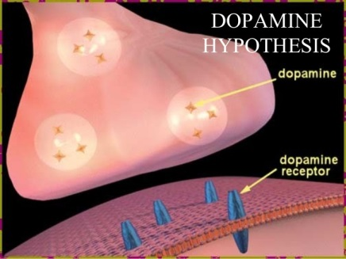
The dopamine hypothesis suggests that an excess of the neurotransmitter dopamine in certain regions of the brain is associated with the positive symptoms of schizophrenia. Messages from neurons that transmit dopamine fire too easily or too often, leading to hallucinations and delusions that are the characteristic positive symptoms of schizophrenia. Schizophrenics are thought to have abnormally high numbers of D2 receptors on receiving neurons, resulting in more dopamine binding and therefore more neurons firing. The key role played by dopamine was highlighted in two sources of evidence.


Drugs that increase dopaminergic activity
Amphetamine is a dopamine agonist i.e. it stimulates nerve cells containing dopamine, causing the synapse to be flooded with this neurotransmitter. ‘Normal’ individuals who are exposed to large doses of dopamine-releasing drugs such as amphetamines can develop the characteristic hallucinations and delusions of a schizophrenic episode. This generally disappears with abstinence from the drug. Likewise, some people who suffer Parkinson’s disease, a neurodegenerative disease categorised by low levels of dopamine, who take the drug L-Dopa top raise their dopamine levels have been found to develop schizophrenia type symptoms (Grilly, 2002).

Drugs that decrease dopaminergic activity
Although there are many different types of antipsychotic drug, they all have one thing in common, i.e. they block the activity of dopamine in the brain. By reducing the activity in neural pathways of the brain that use dopamine as the neurotransmitter, these drugs eliminate symptoms such as hallucinations and delusions. The fact that these drugs (known as dopamine antagonists because they block its action) alleviated many of the symptoms of schizophrenia strengthened the case for the important role of dopamine in this disorder.

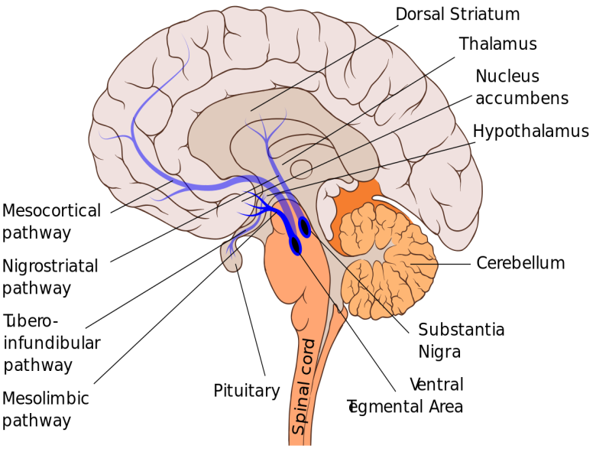
The revised dopamine hypothesis
Davis and Kahn (1991) proposed that the positive symptoms of schizophrenia are caused by an excess of dopamine in subcortical areas of the brain, particularly in the mesolimbic pathway. The negative and cognitive symptoms of schizophrenia are thought to arise from a deficit of dopamine in areas of the prefrontal cortex (the mesocortical pathway). Evidence for this revised hypothesis comes from various sources.

Neural Imaging - e.g. Patel et al (2010), using PET scans to assess dopamine levels in schizophrenic and normal individuals, found lower levels of dopamine in the dorsolateral prefrontal cortex of schizophrenic patients compared to their normal controls.
Animal Studies – Wang and Deutch (2008) induced dopamine depletion in the prefrontal cortex in rats. This resulted in cognitive impairment (e.g. memory deficits) that the researchers were able to reverse using olanzapine, an atypical antipsychotic drug thought to have beneficial effects on negative symptoms in humans.

Evaluation of the Dopamine Hypothesis
Evidence from treatment

Much of the evidence supporting the dopamine hypothesis comes from the success of drug treatments that attempt to change levels of dopamine activity in the brain. The basic mechanism of antipsychotic drugs is to reduce the effects of dopamine and so reduce the symptoms of schizophrenia. For example, Leucht et al (2013) carried out a meta-analysis of 212 studies that had analysed the effectiveness of different antipsychotic drugs compared with a placebo. They found that all drugs tested were significantly more effective than placebo in the treatment of positive and negative symptoms, achieved through the normalisation of dopamine.

Inconclusive supporting evidence

Moncrieff (2009) claims that evidence for the dopamine hypothesis of schizophrenia is far from conclusive. E.g. although stimulant drugs such as cocaine and amphetamine have been shown to induce schizophrenic episodes, such stimulants are known to affect many neurotransmitters other than dopamine. Likewise, evidence for dopamine concentrations in post-mortem brain tissue has either been negative or inconclusive, Moncrieff also points out that other confounding sources of dopamine release, such as stress or smoking, have rarely been considered. Therefore, she suggests, the idea that the symptoms of schizophrenia are caused by the over-activity of the dopaminergic system is not supported by current evidence.
Challenges to the dopamine hypothesis

Noll (2009) claims there is strong evidence against both the original dopamine hypothesis and the revised dopamine hypothesis. He argues that antipsychotic drugs do not alleviate hallucinations and delusions in about one-third of people experiencing these problems. Noll also points out that, in some people, hallucinations and delusions are present even though dopamine levels are normal. Blocking the D2 receptors of these people has little or no effect on their symptoms. This suggests that, rather than dopamine being the sole cause of positive symptoms, other neurotransmitter systems may also produce the positive symptoms associated with schizophrenia.

The Genetic explanation of Mental Illness

One possible explanation of schizophrenia may be heredity i.e. genetics. Schizophrenia tends to run in families, but only among individuals who are genetically related rather than related by marriage. The risk of developing the disorder among individuals who have family members with schizophrenia is higher than it is for those who do not. No one gene is thought to be responsible for this disorder – it’s more likely that different combinations of genes make individuals more vulnerable to schizophrenia. Having these genes does not necessarily mean an individual will develop schizophrenia.

Family Studies
Family studies (Gottesman and Shields, 1991) find individuals who have schizophrenia and determine whether their biological relatives are similarly affected more often than non-biological relatives. Family studies have established that schizophrenia is more common among biological relatives of a person with schizophrenia, and that the closer the degree of genetic relatedness, the greater the risk. For example, in Gottesman and Shield’s study, children with two schizophrenic parents had a concordance rate of 46%, children with one schizophrenic parent a rate of 13% and siblings (where a brother or sister had schizophrenia) a concordance rate of 9%.

Twin Studies

If monozygotic (MZ – genetically identical) twins are more concordant than dizygotic (DZ – who share only 50% of their genes), then this suggests that the greater similarity is due to genetic factors. Joseph (2004) calculated that the pooled data for all schizophrenia twin studies carried out prior to 2001 showed a concordance rate for MZ twins of 40.4% and 7.4% for DZ twins. More recent, methodologically sound studies (e.g. those using ‘blind’ diagnoses where the researchers assessing don’t know whether the twins are MZ or DZ) have tended to report a lower concordance rate for MZ twins than earlier studies. Despite this, however, such studies still support the genetic position because they show a concordance rate for MZ twins that is many times higher than for DZ twins.
Adoption Studies
Because of the difficulties of disentangling genetic and environmental influences for individuals who share genes and environment, studies of genetically related individuals who have been reared apart are used. Probably the most methodologically sound study of this type was carried out by Tienari et al (2000) in Finland. Of the 164 adoptees whose biological mothers had been diagnosed with schizophrenia, 11 (6.7%) also received a diagnosis of schizophrenia, compared to just 4 (2%) of the 197 controls adoptees (those born to non-schizophrenic mothers). The investigators concluded that these findings showed that the genetic liability to schizophrenia had been ‘decisively confirmed.’

Evaluation of genetic explanations

Strong research evidence to support it

There is strong evidence from a variety of different sources to support this explanation. The Gottesman (1991) clearly shows how genetic similarity and shared risk of schizophrenia are closely related. Adoption studies like Tienari’s clearly shows that children of schizophrenia sufferers are still at a heightened risk even though they’re adopted into families with no cases of the disorder. There is overwhelming evidence to suggest that genetic factors make some people much more vulnerable to developing the disorder than others. This does not mean that schizophrenia is entirely genetic, however. There are a number a number of factors in the environment associated with risk of the disorder (which could account for concordance rates of less than 100%), but the available evidence suggests it’s very important.

Common rearing patterns may explain family similarities

Research has shown that schizophrenia tends to run in families. However, many researchers now accept that the fact that schizophrenia appears to run in families may be more to do with common rearing patterns or other factors that have nothing to do with heredity. For example, research on expressed emotion has shown that the negative emotional climate in some families may lead to stress beyond an individual’s coping mechanisms, thus triggering a schizophrenic episode.



MZ twins encounter more similar environments

A crucial assumption underlying all twin studies is that the environment of MZ twins and DZ twins is equivalent. It’s assumed, therefore, that the greater concordance for schizophrenia between MZ twins is a product of greater genetic similarity rather than greater environmental similarity. However, as Joseph (2004) points out, it’s widely accepted that MZ twins are treated more similarly than DZ twins, encounter more similar environments (more likely to do things together) and experience more ‘identity confusion’ (frequently being treated as twins rather than 2 separate identities). As a result, Joseph argues there is reason to believe that the differences in concordance rates between MZ and DZ twins reflect nothing more than the environmental differences that distinguish the two types of twin.

Adoptees may be selectively placed

A central assumption of adoption studies is that adoptees are not ‘selectively placed’ i.e. adoptive parents who adopt children with a schizophrenic biological parent are no different to adoptive parents who adopt children whose background is normal. Joseph (2004) claims that this is unlikely to have been the case, particularly in early studies. In countries like Denmark and the US, potential adoptive parents would have been informed of the genetic background of children prior to selection for adoption. As Kringlen (1987; cited in Jospeh 2004) points out, ‘Because the adoptive parents evidently received information about the child’s biological parents, one might wonder who would adopt such a child.’

Brain Abnormality as an Explanation of Mental Illness

Significant Loss of Brain Gray Matter: Individuals with schizophrenia, including those who have never been treated, have a reduced volume of gray matter in the brain, especially in the temporal and frontal lobes. Recently neuroscientists have detected gray matter loss of up to 25% (in some areas). The damage started in the parietal, or outer, regions of the brain but spread to the rest of the brain over a five year period. Patients with the worst brain tissue loss also had the worst symptoms, which included hallucinations, delusions, bizarre and psychotic thoughts, hearing voices, and depression.

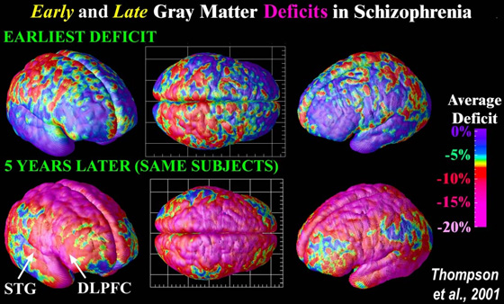

Enlarged Ventricles in the Brain: Individuals with schizophrenia, including those who have never been treated, typically have enlarged ventricles in the brain, as demonstrated in over 100 studies to date.

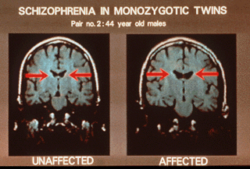

Evaluation
Advances in MRI and PET scanning techniques have made it easier to study brain abnormalities, previously the only technique was postmortem examination.

However, research is correlational, it is not known whether brain abnormalities are a cause or effect of schizophrenia as few have had brain scans before the onset of the disease.
Gottesman et al (2010) Disorders in offspring with two psychiatrically ill parents

Aim
This study aimed to build on previous research on genetic transmission of mental illness and, in an attempt to have a large sample size, was conducted using all register-based diagnoses for each patient reported in the nationwide Danish Central Psychiatric Register.

Procedure
This was a national register-based cohort study conducted in Denmark.
A cohort of more than 2.6 million persons with a link to their biological parents, ignoring legal marital status, and with information on all psychiatric admissions among offspring and parents was established from two Danish registers

Those who had ever received diagnoses of schizophrenia, bipolar affective disorder, or unipolar depressive disorder were identified from the Psychiatric Central Register among a group of parent couples with both parents ever having been admitted to a psychiatric facility from 1 April 1970, to 1 January 2007. For each of these groups of parent couples, their offspring, the eldest reaching age 52 years at follow-up, were checked in the register for admissions with similar or related diagnoses, and cumulative incidences were calculated.

For comparison, cumulative incidences were calculated in the offspring of couples with only one parent ever having been admitted to a psychiatric facility for the selected diagnoses and the other parent never having been admitted.

Results

• The risk of schizophrenia in 270 offspring of 196 parent couples who were both admitted to a psychiatric facility with a diagnosis of schizophrenia was 27.3% (increasing to 39.2% when schizophrenia-related disorders were included) compared with 7.0% in 13,878 offspring from 8,006 couples with only one parent ever admitted for schizophrenia and 0.86% in 2,239,553 offspring of 1,080,030 couples with neither parent ever admitted.
• The risk of bipolar disorder was 24.9% in146 offspring of 83 parent couples who were ever admitted with bipolar disorder (increasing to 36.0% when unipolar depressive disorder was included) compared with 4.4% in 23,152 offspring from 11,995 couples with only one parent ever admitted and 0.48% in 2,239,553 offspring of 1,080,030 couples with neither parent ever admitted.

• Risks of schizophrenia and bipolar disorder in offspring of couples with one parent with schizophrenia and the other with bipolar disorder were 15.6% and 11.7%, respectively.

• The maximal risks of any psychiatric disorders in the offspring of parents both with schizophrenia or both with bipolar disorder were 67.5% and
44.2%, respectively.

• For the general population with no restrictions on parents’ psychiatric admissions, the uncleaned control group of parents, the cumulative incidence was 14.1%. Therefore, in the study population of offspring, only 1 in 7 had been admitted by age 52 years.

Conclusion

• The offspring of dual matings diagnosed with psychosis constitute a super-high-risk sample of psychosis.

• The risk of offspring being admitted to hospital with a diagnosis of schizophrenia is higher if both parents have been admitted with the same diagnosis than for offspring who have either had just one parent admitted with the diagnosis or neither parent ever having been admitted with the diagnosis.

• The risk of offspring being admitted to hospital with a diagnosis of either bipolar disorder or unipolar depressive disorder is higher if both parents have been admitted with the same diagnosis than for offspring who have either had just one parent admitted with the diagnosis or neither parent ever having been admitted with the diagnosis.

• Derived risks of psychosis may be informative for counselling.
• There is evidence to support the genetic explanation of mental illness.

• Derived risks of psychosis may be of use to genetic counsellors to inform personal decisions with regard to marriage, family formation, adoption, and health insurance planning.

• Patterns of transmission may support evolving assumptions about genetic overlap for traditional categories of psychosis.

Evaluation

Common rearing patterns may explain family similarities

Research has shown that schizophrenia tends to run in families. However, many researchers now accept that the fact that schizophrenia appears to run in families may be more to do with common rearing patterns or other factors that have nothing to do with heredity. For example, research on expressed emotion has shown that the negative emotional climate in some families may lead to stress beyond an individual’s coping mechanisms, thus triggering a schizophrenic episode.

Biological treatment of one specific disorder
Drug Therapy for Schizophrenia
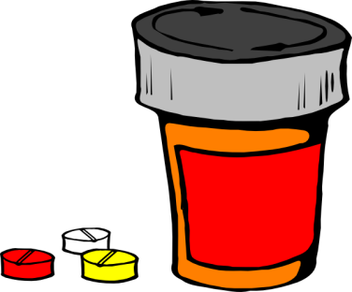
Prior to the introduction of antipsychotic drugs in the 1950s, there was no effective treatment for schizophrenia. Until this time the standard treatment was a long term stay in a psychiatric hospital and hoping for some improvements in symptoms. Following the discovery of dopamine in 1952, drugs were developed that had a direct effect on this neurotransmitter. Some drugs, such as amphetamines were found to create symptoms in health people, while others markedly reduced symptoms in people who were severely ill. Drugs that had the latter effect consequently became known as antipsychotics and were used in drug therapy.

Antipsychotics
Drugs that are the most effective in treating the most disturbing forms of psychotic illness, such as schizophrenia and manic depression (bipolar) are called antipsychotics. Antipsychotics help the person with the disorder function as well as possible in their life, while at the same time increasing their feelings of subjective well-being. Antipsychotics are usually recommended as the initial treatment for the symptoms of schizophrenia, after which clinicians will tend to use a combination of medication and psychological therapies. All antipsychotics work by reducing dopaminergic transmission, i.e. reducing the action of dopamine in areas of the brain associated with schizophrenic symptoms.
- Typical antipsychotics (such as chlorpromazine) are used primarily to combat the positive symptoms such as hallucinations and thought disturbances – products of an overactive dopamine system.
- Atypical antipsychotics (such as clozapine) also combat these positive symptoms but they are also claimed to have some beneficial effects on negative symptoms as well.

Typical Antipsychotics

Typical antipsychotics (also known as ‘conventional’ or ‘first-generation’ antipsychotics) were developed in the 1950s. The basic mechanism of the typical antipsychotics is to reduce the effects of dopamine and so reduce the symptoms. Typical antipsychotics are dopamine antagonists in that they bind to but do not stimulate dopamine receptors (particularly the D2 receptors in the mesolimbic dopamine pathway), thus blocking their action. By reducing stimulation of the dopamine system in the mesolimbic pathway, antipsychotic drugs such as chlorpromazine eliminate the hallucinations and delusions experienced by people with the disorder.
Hallucinations and delusions usually diminish within a few days of beginning medication, although other symptoms may take several weeks before a significant improvement is noted. The effectiveness of the dopamine antagonists in reducing these symptoms led to the development of the dopamine hypothesis. Kapur et al (2000) estimate that between 60% and 75% of D2 receptors in the mesolimbic pathway must be blocked for these drugs to be effective. Unfortunately, in order to do this, a similar number of D2 receptors in other areas of the brain must also be blocked, leading to undesirable side effects. This represents the high cost of using typical antipsychotics to treat schizophrenia. There are several dopamine pathways in the brain and it appears that blocking dopamine receptors in only one of them is useful. Whereas blocking dopamine receptors in other the remaining pathways may be harmful for the person. This problem has been addressed by the development of atypical antipsychotic drugs.

Atypical antipsychotics

Atypical antipsychotic (also known as ‘second-generation’ antipsychotics) were so called because of three main differences to the first-generation typical antipsychotics: They carry a lower risk of extrapyramidal side effects, have a beneficial effect on negative symptoms and cognitive impairment, and are suitable for treatment-resistant patients. As with the typical drugs, these also act on the dopamine system by blocking D2 receptors. However, they only temporarily occupy the D2 receptors and then rapidly dissociate to allow normal dopamine transmission. It is this characteristic (i.e. rapid dissociation) of atypical antipsychotics that is thought to be responsible for the lower levels of extrapyramidal side effects found with these drugs compared to conventional drugs. Because atypical drugs, such as clozapine, have very little effect on the dopamine systems that control movement, they tend not to cause the movement problems found with typical antipsychotics.
Rapid dissociation is one feature of atypical antipsychotics that distinguish them from typical antipsychotics, but there are others. Typical antipsychotics block only D2 (dopamine) receptors. However, atypical antipsychotics have a stronger affinity for serotonin receptors and a lower affinity for D2 receptors. It is this characteristic that explains the different effects of atypical compared to typical antipsychotics.

Differences
- Typical antipsychotics: proven effectiveness of positive symptoms of schizophrenia.
- Atypical antipsychotics: Proven effectiveness on positive symptoms and a claimed effect on both negative symptoms and cognitive impairment.
Evaluation of Drug Therapy
Antipsychotics versus placebo

Support for the effectiveness of antipsychotics comes from studies that have compared relapse rates for antipsychotics and placebos. Leucht et al (2012) carried out a meta-analysis of 65 studies published between 1959 and2011, and involving nearly 6000 patients. All patients had been stabilised on either typical or atypical antipsychotics. Some of these patients were taken off their medication and given a placebo instead. The remaining patients remained on there regular antipsychotic. Within 12 months, 64% of those patients who had been given the placebo had relapsed compared to 27% of those who stayed on the antipsychotic drug.

Extrapyramidal side effects

Typical antipsychotics can sometimes cause movement problems for the patient. These are called extrapyramidal effects because antipsychotic drugs appear to impact on the extrapyramidal area of the brain, which helps control motor activity. The most common are the Parkinsonian and related symptoms, so called because they resemble the features of Parkinson’s disease. More than half of the patients taking typical antipsychotics experience these problems. When people take antipsychotic drugs for an extended period, a second type of extrapyramidal effect may occur – tardive dyskinesia, i.e. involuntary movements of the tongue, face and jaw. These side effects can be so distressing for the patient that other drugs have to be given to control them, or the patient may stop taking their antipsychotic medication.

3. The Behaviourist Explanation of Mental Illness

Behaviourist Explanations for Phobias (Anxiety Disorders)

The approach suggests that behaviour is learned, as distinct from being inherited. For that reason it is sometimes called the learning theory. Behaviourists use the word ‘conditioning’ to mean ‘learning’, so something that is unconditioned is unlearned and something that is conditioned has been learned.

Phobias are seen as learnt behaviour, either through classical conditioning, operant conditioning or social learning theory.


Classical Conditioning – Watson & Rayner (1920) conditioned a baby boy known as Little Albert to fear white rats.
For several weeks, Albert played happily with a white rat showing no fear. One day, while he was playing with the rat, the experimenters struck a steel bar with a hammer close to Albert’s head. Albert was very frightened by the noise. This was repeated each time he reached for the rat. Albert then developed an intense fear of white rats (and Dr. Watson!).

UCS (Noise) UCR (Fear)

UCS (Noise) + CS (Rat) UCR (Fear)

CS (Rat) CR (Fear

Behavioural Explanation – The Two Process Model

Orval Hobart Mowrer (1947) proposed this model to explain how phobias are learned. The first stage is classical conditioning and the second – operant conditioning.

Classical Conditioning: Initiation (process 1)
A phobia is acquired through association, like in the Watson and Raynor study. So you have a neutral stimulus that is paired with an unconditioned stimulus and results in a new response being learned. In the Albert study, by pairing the loud noise with the furry object the furry object acquired the same properties as the UCS and produced the fear response: now a conditioned response.

So the same process can explain why someone develops a fear of a dog after being bitten:
- Being bitten (UCS) creates the fear (UCR)
- Dog (NS) associated with being bitten (UCS)
- Dog (now CS) produces fear response (now CR)

Operant Conditioning: Maintenance (process 2)

Through classical conditioning a phobia is acquired. But this doesn’t explain why people continue to feel fearful.
The next step involves negative reinforcement within operant conditioning. The likelihood of a behaviour being repeated is increased if the outcome is rewarding. In the case of a phobia, the avoidance of (escape from) the phobic stimulus reduces fear and is thus reinforcing. Negative reinforcement (escape from an unpleasant situation). The person avoids the anxiety caused by, for example the dog, by avoiding them completely.

So in the two-process model phobias are acquired through classical conditioning but maintained through operant conditioning (negative reinforcement).

Social Learning Theory

This theory is not part of the two-process model but is another behaviourist theory.

Phobias may also be acquired through the modelling of others. E.g. seeing a parent respond to a spider with extreme fear may lead a child to acquire similar behaviour because the behaviour appears rewarding (vicarious reinforcement) i.e. the fearful person gets attention


Ost’s example of blood and injection phobia being more common in first degree relatives can be explained by this theory. A mother who is afraid of injections is likely to pass this fear on through her own anxiety when she takes her child for its immunisations.
Evaluation of behavioural explanations

The importance of classical conditioning

People do often recall a specific incident when their phobia appeared (Sue et al 1994). Although not everyone can remember a specific incident it is argued that it probably did happen but people have forgotten (Ost 1987).
Sue et al suggests that different phobias may be the result of different processes. E.g. agoraphobics most likely to recall a specific incident whereas people with specific phobias e.g. spiders cited modelling as the cause.
Diathesis-stress model

Not everyone who is bitten by a dog develops a phobia of a dog (DiNardo 1988). Therefore behavioural explanations cannot account for this very well. This could be explained by the diathesis-stress model. I.e. we may inherit a genetic vulnerability to for developing a mental disorder. However the disorder will only manifest if triggered by a life event, such as being bitten by a dog. So a dog bite will only lead to a phobia in those with the genetic vulnerability. Nature AND nurture…not just nurture.

Support for social learning

An experiment by Bandura and Rosenthal (1966) supported the social learning explanation. In the experiment the model acted as though he were in pain whenever a buzzer sounded . Later on those participants that had observed this showed an emotional reaction to the buzzer, demonstrating an acquired ‘fear’ response.



The Two-Process model ignores cognitive factors
There are cognitive factors that can’t be explained through behaviourism. The cognitive approach proposes that phobias may develop as a consequence of irrational thinking. E.g. a person in a lift may think: ‘I could become trapped in here and suffocate.’ (an irrational thought). Such thoughts create extreme anxiety and may trigger a phobia.
The value of this theory is that it has practical applications for cognitive treatments such as CBT which has been more useful than behaviourist treatments at times. Social phobia responds better to CBT (Engels et al 1993).

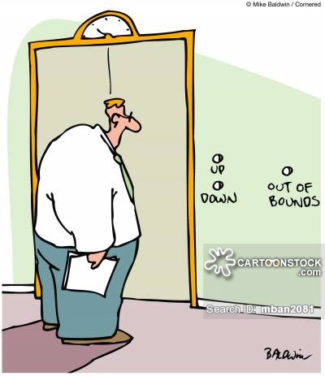

Biological Preparedness
The fact that phobias don’t always develop after a traumatic experience may be explained in terms of biological preparedness. Seligman (1970) argued that animals, including humans, are genetically programmed to rapidly learn an association between potentially life threatening stimuli and fear. These stimuli are referred to as ancient fears – things that would have been dangerous in our evolutionary past. It would have been adaptive to learn to avoid such stimuli.
This would explain why we are much more likely to have phobias of snakes and spiders than of cars and toasters. Bregman (1934) failed to condition a fear response in infants by pairing a loud bell with wooden blocks. It may be that fear responses are only learned with live animals, a link with ancient fears.
This suggests behavioural explanations alone can’t be used to explain the development of fears.



The Cognitive Explanation of Mental Illness
Cognitive Approach to Explaining Depression

In terms of understanding abnormality, cognitive psychologists are most concerned with how irrational thinking leads to a mental disorder. As depression is very much characterised by negative, irrational thinking, cognitive explanations are particularly appropriate.
There are 2 examples of the cognitive approach to explaining depression. Both developed by Americans in the 1960s – Albert Ellis and Aaron Beck.

Aaron Beck’s Negative Triad (1967)

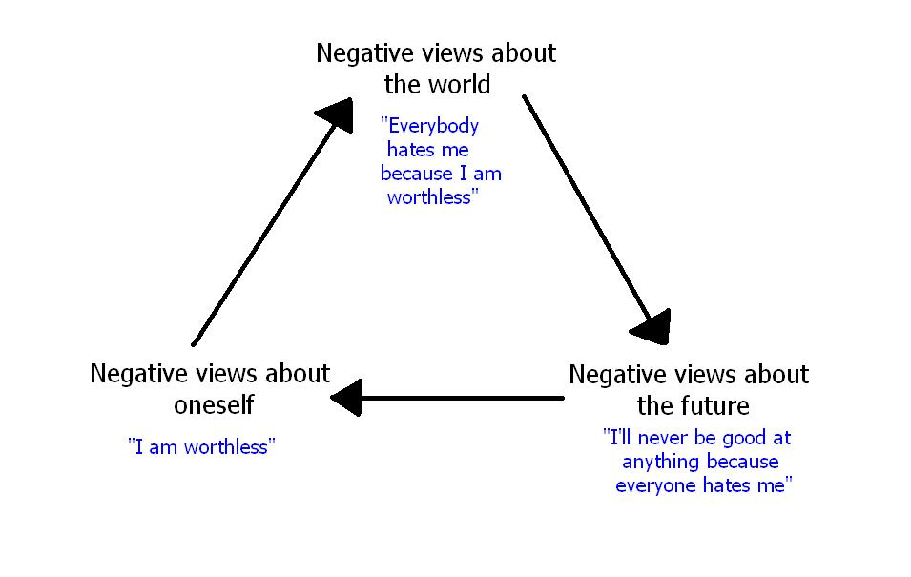
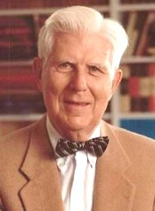
Negative Schema
Depressed people have acquired a negative schema during childhood – a tendency to adopt a negative view of the world. This could happen because of a variety of factors. We have a self-schema about ourselves. We use schemas to interpret the world, so if we have a negative self-schema we interpret all information about ourselves in a negative way.

The Self: - ‘I’m undesirable’
The World: - ‘I understand why everybody hates me, everyone else is so much better than me’
The Future: - ‘Things will never change for me’

Beck suggests three parts to this cognitive vulnerability to depression.
- Faulty information processing – always seeing the negative aspects of a situation rather than the positives.
- Negative self-schemas.
- The negative triad.

This pessimistic view becomes a self-fulfilling prophecy and lead to cognitive bias. Depressed people tend to focus on the negative aspects of their lives and ignore the positive ones; therefore they become trapped in a vicious circle of depression.

Task: - Give examples of negative or irrational thought patterns which people may have.

Ellis’ ABC Model (1962)

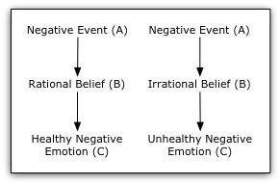
Albert Ellis also focuses on irrational beliefs as the source of depression. It is not what happens to someone that causes depression, but how they deal with it.

A = Activating Event: e.g. getting fired from your job, death of a family member
B = Belief: these can be rational or irrational e.g. ‘I lost my job because they were overstaffed’ or ‘They always had it in for me’
C = Consequence: Rational beliefs lead to healthy emotion responses, whereas irrational beliefs lead to unhealthy ones and result in depression.

Task: - Complete the table using the ABC Model for two responses to the same negative event e.g. failing your driving test.

A – Failing your driving test
B Rational belief |  | B Irrational belief
C Healthy Negative Emotion |  | C Unhealthy Negative Emotion
Ellis’ Mustabatory Thinking

The source of irrational beliefs lies in mustabatory thinking – thinking that certain ideas or assumptions must be true in order for an individual to be happy. Ellis identified the 3 most important irrational beliefs.
- I must be approved of or accepted by people I find important.
- I must do well, or very well, or I am worthless.
- The world must give me happiness or I will die.

Others include, “others must treat me fairly & give me what I need” and “people must live up to my expectation or it is terrible!”

An individual who holds such assumptions is bound to be, at the very least, disappointed; at worst, depressed.
An individual who fails an exam becomes depressed not because they failed the exam but because they hold irrational beliefs regarding that failure.


Evaluation of cognitive explanations of depression

Support for the role of irrational thinking
The cognitive view for depression is supported by research. Hammen and Krantz (1976) found depressed ppts made more errors in logic when asked to interpret material than non-depressed ppts. Bates et al (1999) found depressed ppts who were given negative automatic thought statements became more and more depressed, thus supporting negative thinking leads to depression.
But could it also be that the depression is causing the negative thinking rather than the other way around? Just because there’s a link between negative thinking and depression – it doesn’t mean that it actually causes depression.

Blames the client rather than situational factors
The cognitive approach suggests that it’s the client who is responsible for their disorder. In one sense, this is good as it gives them power to change the way things are.
However, there are disadvantages. It means that the therapist and client might overlook situational factors could have contributed to the disorder. The disorder is in the client’s mind and recovery lies in changing that, rather than looking at another aspect that could be changed in their environment and life.

Practical applications in therapy
Both of these theories have been applied to CBT (a treatment for depression). CBT is consistently found to be the best treatment for depression especially when used in conjunction with drug treatments. (Cuijpers et al 2013).
The particular reason these explanations are so useful is that they have specific implications for the success of the therapy and the therapy supports the explanation. If depression is alleviated by challenging irrational thinking then this suggests such thoughts had a role in the depression in the first place.

Further Evaluation…

Irrational beliefs may be realistic
Not all irrational beliefs are ‘irrational’, they may simply seem irrational. Alloy and Abrahmson (1979) suggest that depressive realists tend to see things for what they are (with normal people viewing the world through rose tinted glasses). They found that depressed people gave more accurate estimates of the likelihood of a disaster than normal controls. The sadder, but wiser effect.

Alternative explanations
The biological approach holds some very strong evidence that the explanation of depression lies within neurotransmitters and genes rather than thought processes. Zhang et al 2005 – low levels of serotonin in people with depression.
The success of drug therapies (anti-depressants) suggests neurotransmitters play a role.
At the very least – diathesis-stress must be advisable.
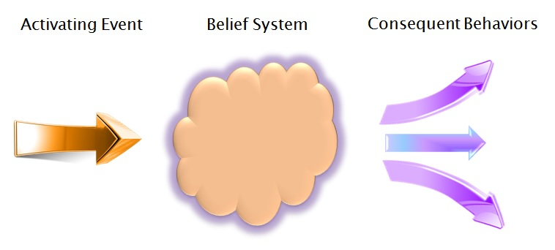
The Psychodynamic Explanation of Mental Illness


As you will remember from studying Freud’s case study of Little Hans in Component 2, mental illness is likely to arise as the result of unresolved childhood conflicts. Unconscious motivations will manifest themselves in abnormal behaviours – mental illness. Freud explained Little Hans’ phobias of horses as a displaced fear of his father due to an unresolved Oedipus complex.

Conflicts between the Id, Ego and Superego can create anxiety. Freud believed that the Ego would usually prevent us from harming ourselves and the Superego from harming others. The Ego deploys defence mechanisms to prevent us from harming ourselves, but overuse of these defence mechanisms can lead to inappropriate or disturbed behaviour. Denial and repression may prevent us from dealing with childhood trauma, which can lead to mental illnesses such as depression in later life.

The role of the Ego can explain Schizophrenia. The Ego is there to control the demands of the Id and the power of the Superego. If the Ego does not develop properly in childhood, sometimes due to a cold, rejecting mother, the Id is left in charge of the personality. If the Id is in control of the personality it is difficult to distinguish between reality and fantasy. The person could regress to a child-like state where reality and fantasy produce a distorted view of the world and schizophrenic symptoms appear.

Psychodynamic Treatments

Psychoanalysis was the first ‘talking cure’. Freud used free association and dream analysis to try and unlock the unconscious. He saw dreams as the ‘royal road’ to the unconscious. Freud believed that once unconscious motivation and earl childhood trauma needed to be address in order to cure mental illness.

Psychotherapy is not without its critics. It is a long process, Tschuschke et al (2007) found in a study of 450 patients that outcomes were better for prolonged treatment. However, it is not universally thought to be effective. Most therapy is combined with drug treatment for maximum effect.
Szasz (2011) The myth of mental illness; 50 years later.

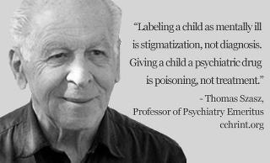
www.szasz.com

Thomas Szasz wrote an essay in 1960 called “The Myth of Mental Illness’. Thomas Szasz was part of a group known as the anti-psychiatrists, which also included Laing.

Background/context

Szasz’s views focus on western ideas about mental illness. He is rejecting the dominant medical model, prevalent in Western societies. He argues that changes in treatments are a result of increasing understanding, and we now accept that mental illness exists, but there is more research to be done.

Szasz's view is that there is no such thing as mental illness and "disease only means bodily disease" and his writings debate over whether illness must refer to bodily disease.

He still argues that mental illness is a myth, it should just be seen as behaviours that disturb others.

He proposes that mental patients should be seen as active players in real life dramas, not victims of processes out of their control

Method

The article critiqued changes in beliefs and concepts about mental health and changes in USA healthcare since the 60's, it is not a study since it didn't include a procedure or participants.

The article has 4 sections
1- 50 years of change in US mental healthcare
2- Mental illness, medical or legal?
3- Mental illness as a metaphor
4- revisiting his book, 'myth of mental illness'

Findings

- 50 years of change in US Mental Healthcare
In the 50's Szasz said that the responsibility of US healthcare should be up to the federal government.

Mental patients were considered incurable, confined and cared for by physicians paid by the government.

Non-psychiatric physicians in the private sector treated patients, paid by clients or their families.

Since then, all mental health care is run by the government and paid for by public money.

Mental health professionals are now responsible for preventing their patients from causing danger to themselves or others.

- Mental Illness, medical or legal?
Old 'diseases' like homosexuality disappear and new ones like ADHD appear.

Mental illness has been decided to be a disease like physical ones that can be treated medically.

Szasz says that the claim that mental illness is a diagnosable disorder of the brain is not scientific; it is an error and a deception, a metaphor
He thinks mental hospitals are like prisons.

3 – Mental illness as a metaphor
The idea that mental illness isn't a medical problem is not popular, Szasz says the physician who concludes a person who has a mental illness suffers from a brain disease, discovers that the person was diagnosed and actually had a bodily illness.
Szasz argues that if all the conditions called mental illnesses proved to be brain diseases, there would be no need for "mental illness".
He says that the old perspective on the tragic nature of life has been replaced with a dehumanised one. Szasz uses Macbeth as an illustration, he was overcome with guilt, Lady Macbeth "goes mad" and the doctor says he cannot cure her, she needs to minister herself meaning she needs to work out her internal mental issues out herself.

He says behaviour labelled, as mental disorder is the product of medicalisation of disturbing behaviours. Individuals with bodily illnesses are not deprived of liberty, but mentally ill patients can be deprived of freedom that is the violation of human rights. Diagnoses are in the hands of licensed physicians, so technically mental illness is in the eye of the beholder.

4- Revising the Myth of Mental Illness
Many critics misread his book, according to Szasz, they apparently overlook the fact that it was meant to be an effort to recast mental illness from a medical problem to a linguistic-rhetorical phenomenon.
Most sympathetic appraisals of his text have come from physicians who do not feel threatened by his opinions.

Critics of psychiatry, journalists and the public regularly fail to distinguish between counselling clients and coercing captives of the psychiatric system. He also believes people should be able to decide if they want to live or not.

Conclusions

Mental illness is in the eye of the beholder.
Mental illness is a metaphor.
Psychiatry is a pseudo science.
It is now a legal concept, not a medical one.
"Mentally ill" people should have rights and liberties to define and control their own lives.

Evaluation Task

Szasz ideas are certainly controversial! You will be split into two teams:

For -Szasz has a point
Against – Szasz is completely wrong!

Your task is to research your position thoroughly in your groups. Prepare a presentation to argue your case (poster, PowerPoint, speech). You will then present your case as a group and debate the issues.
Non-biological treat of one specific disorder
Behavioural Treatments

Behavioural therapies are based on the ideas of classical and operant conditioning. Behavioural therapies aim to change specific behaviours. They assume that both ‘normal’ and ‘abnormal’ behaviours are learnt. Therefore they can be re-learned through conditioning.

This conditioning is achieved either through a slow process of gradual exposure or one single intense exposure. The treatment is complete when the patient can relax in the presence of their most feared stimulus. Slow process (gradual exposure) – Systematic Desensitisation.
One single intense exposure – Flooding.

Behavioural therapy – Classical Conditioning.
Behaviour therapy is often used to treat Phobias. It assumes that: -
- Phobias are learnt by classical conditioning and
- They can be unlearnt by a similar process.
Phobias can be removed by counterconditioning – learning a new response to the feared stimulus. This is the principle behind Systematic Desensitisation.

Systematic Desensitisation


One of the reasons that phobias persist is that phobics avoid the stimulus so there’s no opportunity to learn that the feared stimulus is not so fearful after all. Joseph Wolpe (1958) developed a technique where phobics were introduced to the feared stimulus gradually.

Systematic desensitisation (SD) is based on classical conditioning. If the sufferer can learn to relax in the presence of the phobic stimulus then they are cured. Essentially, a new response to the phobic stimulus is learned (paired with relaxation rather than anxiety). The learning of a different response is called counterconditioning. It’s impossible to be afraid and relaxed at the same time, so one emotion prevents the other. This is called reciprocal inhibition.

This approach was developed by Joseph Wolpe (1958). It takes 3 main processes:
- Relaxation
- Anxiety hierarchy
- Gradual exposure

Step 1 – Clients are taught relaxation techniques
Step 2 – With the help of a therapist, clients construct a fear hierarchy – a list of feared objects or situations ranked from the least to the most feared. E.g. a person with arachnophobia might imagine a spider in various situations from a picture in a book (least feared) to crawling over their hand (most feared).
Step 3 – In the presence of the therapist, the client then confronts each item in the hierarchy while they are in a state of deep relaxation. They start with the least feared item and move on once they feel relaxed and unafraid in its presence. This confrontation may be real or imagined. The process continues until they reach the top of the hierarchy and feel relaxed in the presence of all the items. If the systematic desensitisation works, clients have been counter conditioned – they have learnt a new response to a stimulus. They no longer associate the object or situation with fear.

Evaluation

- Systematic desensitisation is the main treatment for phobias. It is very effective - McGrath 1990 found that 75% of people with specific phobias improved with systematic desensitisation therapy. Other research shows that it is effective in the treatment of specific phobias. Gilroy (2003) followed up 42 patients who had been treated for spider phobia in 3 45 minute sessions of systematic desensitisation. A control group was treated by relaxation, not exposure. At both 3 months and 33 months the SD group were less fearful than the relaxation group. So it is very effective.
- Behavioural therapies for dealing with phobias are generally fast and require less effort (on the patient’s behalf) than some other cognitive therapies like CBT for example. This means that it is useful for people who lack insight into their motivations or emotions, such as children or patients with learning difficulties.
- Most patients tend to prefer it because it doesn’t involve trauma like flooding does. It also has some elements which are really pleasant – relaxation. This is reflected by the low refusal rates and dropout rates.
- However, there are ethical issues and protection from harm needs careful consideration.
- It is an individualised therapy and so can be expensive and time consuming.
- Not appropriate for all phobias - Ohman et al (1975) suggest that SD may not be as effective in treating phobias that have an underlying evolutionary survival component (e.g. fear of the dark, heights or dangerous animals), than in treating phobias which have been acquired through personal experience.

Flooding
An alternative to the gradual progression in SD is to just have one long session where the patient experiences their phobia at its worst while at the same time practising relaxation. The session continues until the patient is fully relaxed.


This approach directly exposes clients to the objects or situations they fear. It hits them hard. For example, someone with a fear of heights is taken to the top of a tower block and encouraged to stay there. In theory, flooding the client – exposing them repeatedly to the feared stimulus – will allow them to see that there is no basis for their fear. If the therapy works, this leads to the extinction of the fear.

Flooding stops phobic responses quickly. Without the avoidance behaviour, the patient learns very quickly that the phobic stimulus is harmless. In classical conditioning terms this is known as extinction.
The procedure can be in vivo (actual exposure) or can be done through virtual reality. The session can last 2-3 hours but patients can be cured in one session.
A person’s fear response has a time limit. As adrenaline levels naturally decrease, a new stimulus response link can be learned between fear stimulus and relaxation.

Evaluation
- Flooding is an extreme form of therapy and therefore rather ethically dubious. Clients find it very frightening and discomforting. Because of this many therapists only use it as a last resort, when other treatments have failed.
- Good Effectiveness - For those who choose this and stick to it, it is relatively quick (compared to CBT) and effective. Choy et al reported that both SD and flooding were effective but flooding was most effective. Craske et al 2008, concluded that SD and flooding were equally effective. It’s also cost-effective. As many patients are cured quite quickly, it makes the treatment cheaper than others.
- Less effective for some types of phobia - Although it’s highly effective for some phobias, it’s less effective for complex phobias like social phobias. This may be because social phobias have cognitive aspects. They experience unpleasant thoughts – not just an anxiety response. So this type of phobia would benefit from cognitive therapies like CBT that tackle irrational thoughts rather than flooding.
- Individual Differences - Flooding is not for every patient (or therapist!) It can be highly traumatic. Patients are made aware of this beforehand but even then, they may quit during the treatment, which reduces the overall effectiveness. Time and money may also be wasted preparing patients if patient’s quit or refuse to start.





Exam Questions

SAMS

1) (a) Outline one definition of abnormality. [2]
(b) Explain why labelling people ‘abnormal’ could be considered unethical. [3]
2) Rosenhan (1973) hypothesised that psychiatrists cannot reliably tell the difference between people who are sane and those who are insane. With reference to the key research, discuss how classification of mental illness can result in ‘stickiness of labels’. [5]
3) Suggest how biological treatment can be used to treat one specific disorder. [5]
4)* Compare a cognitive explanation with one other explanation of mental illness. [10]
5)* Discuss the nature/nurture debate in relation to the biological explanation of mental illness. [10]

June 2017
1) (a) Outline how mental hospitals failed to detect sanity in the research by Rosenhan (1973). [2]
(b) Discuss ethical considerations of the research by Rosenhan (1973). [6]
2) Richard and Wendy are parents. They have just been told that their son has a psychotic disorder. They don’t understand what this means.
How might a clinical psychologist explain to Richard and Wendy the characteristics of a psychotic disorder? [6]
3) (a) Outline a biological treatment of one specific disorder. [5] (b) Discuss one strength and one weakness of the biological treatment referred to in your answer to question 3(a). [6]
4)* To what extent are alternatives to the medical model of explaining mental illness scientific? [10]
June 2018

1 (a)Outline a non-biological treatment of one specific disorder. (5)
(b) Discuss one strength and one weakness of the non-biological treatment referred to in your answer to 1a. (6)
2a) In the key research by Szasz (2011), the author states that ‘there is no such thing as mental illness.” How does Szasz defend this claim? [3]
(b) Evaluate Szasz’s view that “there is no such thing as mental illness.” [5]
3 Explain how the key research by Rosenhan (1973) contributes to an understanding of individual, social and cultural diversity. [6]
4* To what extent are explanations of mental illness determinist? [10]
June 2019
- Outline one way of categorising mental disorders. (3)
- When people feel unwell, they often consult the website of the NHS. The way illnesses are described on the NHS website needs to be extremely clear.

Describe the characteristics of an affective disorder in a way that could be included on the NHS website. (5)

- Explain how the key research by Gottesman et al (2010) contributes to the medical model of mental illness. (5)
- Assess the usefulness of the key research by Szasz (2011). (6)
- Compare the behaviourist explanation of mental illness with either the humanistic or the psychodynamic or the cognitive neuroscience explanation of mental illness. (8)
- Discuss ethical considerations concerning the biological treatment of one specific disorder. (8)

